Michael McClelland
www.mikemcclelland.net

Demo Reel Shot List

Shot List:_______________________________________________________________

All Artwork was created by Michael McClelland, using 3d Studio Max, Photoshop, and Painter, unless otherwise specified. The Music is “Coyote” by Yo-Yo Ma and Bobby McFerrin.

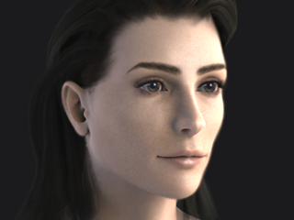

Young Woman
Hi-resolution render using Brazil (HDRI with 1 specular light), 3d Studio Max and Photoshop. Created as a portfolio piece. All textures were hand painted except for the specular/bump map, which was a heavily painted photo.

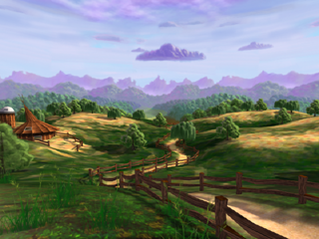
Hobbiton Demo, The Hobbit
Pre-rendered animation of in-game art
Technical test for 3D “painted look” to determine the look of the game
There is also an identical real-time version of this

Paul Haskins: source texture for wood fence,

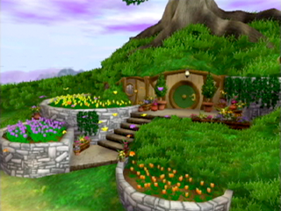
Hobbiton Level, The Hobbit
In-Game, Nintendo Gamecube
Bag End Exterior

Paul Haskins: steps texture
Mike Fong ( http://www.fongwerx.com/ ): butterfly models and animation
Carrie Meade: potted plants next to door, lantern, and green door texture

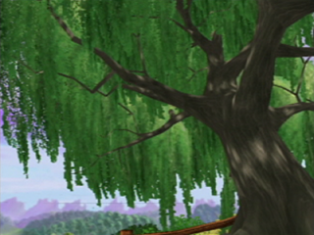
Hobbiton Level, The Hobbit
In-Game footage, Nintendo Gamecube
Demonstrates scrolling light maps and animated trees

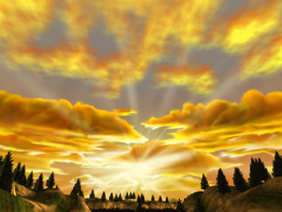
Trollhole Level, The Hobbit
Pre-rendered animation of in-game art
Exterior cliff, flying over part of the Roast Mutton Level
Rendered to simulate real-time

Luke Gustafson: valley floor, lowest rock hills, boulders

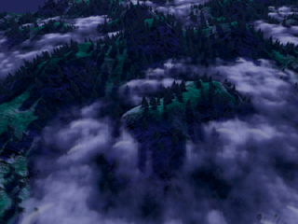
Eagleflight Test, The Hobbit
Pre-rendered animation of in-game art
Technical Test for proposed Eagleflight Level
Rendered to simulate real-time

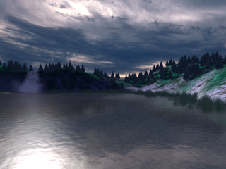
Eagleflight Lake Test, The Hobbit
Though this is pre-rendered, this was a test to try to determine the look of our in-game water and our art style. Everything other than the water is using real-time geometry and textures.

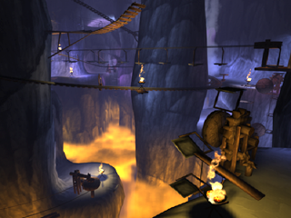
Swordlight Level, The Hobbit
Pre-rendered animation of in-game art
Interior of Misty Mountain goblin caves before Golem’s cave
Rendered to simulate real-time

Paul Haskins: Source texture for wood gears
Blur Studios: 3d Max Electric Plug-In used for particle fire

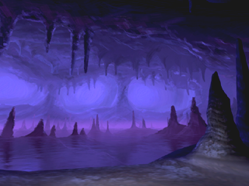
Golem’s Cave Level, The Hobbit
Pre-Rendered Animation of In-Game Art

This was another early experiment in “the painted look.”

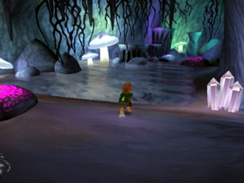

Trollhole Level, The Hobbit
In-Game, Nintendo Gamecube
Cliff caves interior—this was what the final in-game water looked like.

(Bilbo Baggins created and animated by Tom Heineman, Mike Fong ( http://www.fongwerx.com/ ), Brad Marques ( www.artofbrad.com ), Jessie Slate, Martin L'Hereaux, and Martin Coven)

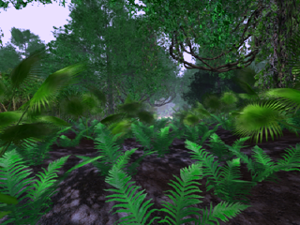
Jungle Demo, Turok Evolution
Pre-Rendered Animation of Simulated Real-time Scene
Created for in-house Green Light committee.
Lit with Projection lights—No Shadows

Tal’ Set, High-Poly Head, Turok Evolution
Spline model of main character created for E3 marketing animation.

I only created the head and shoulders—other artists eventually added the torso and hands. Modeled from a character sketch created by Brian Hagan ( www.artofhagan.com ).

I modeled the ears while at Hasbro for the game X-COM Genesis.

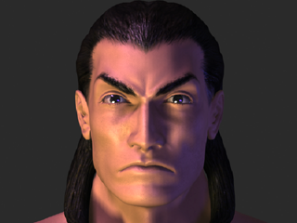

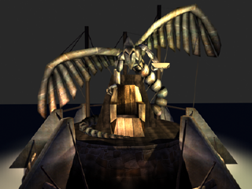
River People Elder’s Statue, Turok Evolution
Pre-Rendered Animation of Real-Time Geometry

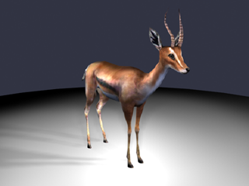
Gazelle Model, Turok Evolution
1188 triangles—real-time model

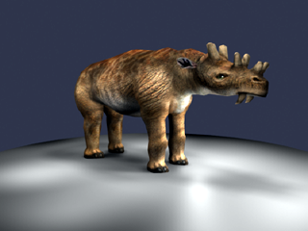
Uintatherium Model, Turok Evolution
2000 triangles—real-time model

This is the ancestor of the modern deer—I don’t think they knew what one looked like before they asked me to model it.

