Michael McClelland
www.mikemcclelland.net

Video Index:
0:00-2:43 Demo Reel
2:43-3:46 Additional 2D artwork (same as included printouts)

All Artwork was created using 3d Studio Max 4.0, Photoshop 5.0, and Painter 6.0

Stevan Hird did the render programming for all the in-game footage shown, as well as the programming for reflective water, the skyboxes, the materials system, and the animated trees.

Shot List:_______________________________________________________________
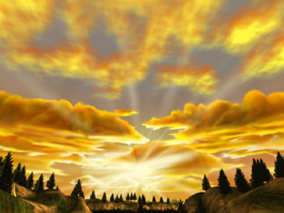
Trollhole Level, The Hobbit
Pre-Rendered Animation of In-Game art
Exterior Cliff, flying over part of the Roast Mutton Level

Luke Gustafson: valley floor, lowest rock hills,
boulders (Roast Mutton Level)

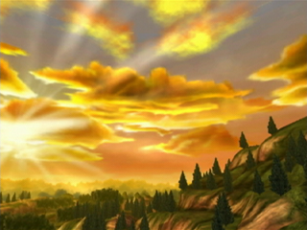
Trollhole Level, The Hobbit
In-Game, Nintendo Gamecube
Exterior Cliff

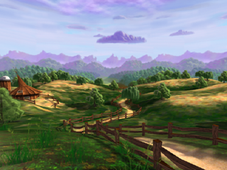

Hobbiton Demo, The Hobbit
Pre-Rendered Animation (available as Real-Time Demo)
Technical Test for 3D “painted look”

Paul Haskins: source texture for wood fence

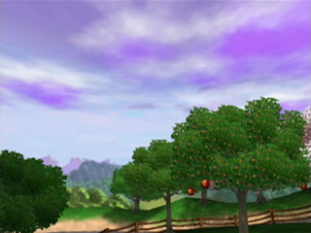
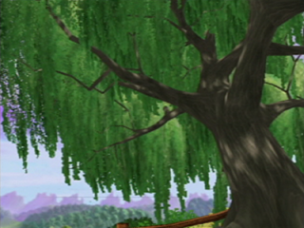
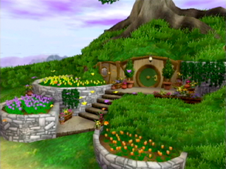
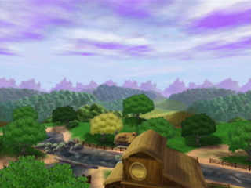
Hobbiton Level, The Hobbit
In-Game, Nintendo Gamecube

Paul Haskins: source texture for wood fence

Hobbiton Level, The Hobbit
In-Game, Nintendo Gamecube
demonstrates scrolling light maps and animated trees
Hobbiton Level, The Hobbit
In-Game, Nintendo Gamecube
Bag End Exterior

Paul Haskins: steps texture
Mike Fong ( http://www.fongwerx.com/ ): butterfly models and animation
Carrie Meade: potted plants, lantern, and green door texture

Hobbiton Level, The Hobbit
In-Game, Nintendo Gamecube

Paul Haskins: source texture for wood fence

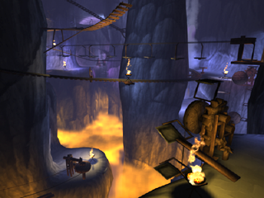
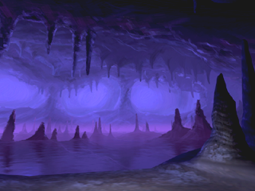
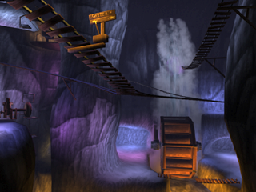
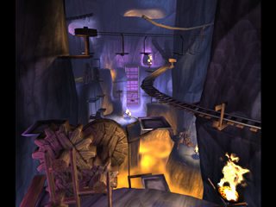
Swordlight Level, The Hobbit
Pre-Rendered Animation of In-Game Art
Interior of Misty Mountain Goblin Caves before Golem’s Cave

Note: This Level was chosen to demo the game at E3

Paul Haskins: Source texture for wood gears
Blur Studios: 3d Max Electric Plug-In used for particle fire
Golem’s Cave Level, The Hobbit
Pre-Rendered Animation of In-Game Art

This was another early experiment in “the painted look.”
It’s actually a part of the swordlight level now
Swordlight Level, The Hobbit
Pre-Rendered Animation of In-Game Art
Swordlight Level, The Hobbit
Pre-Rendered Animation of In-Game Art

Paul Haskins: Source texture for wood gears
Blur Studios: 3d Max Electric Plug-In used for particle fire

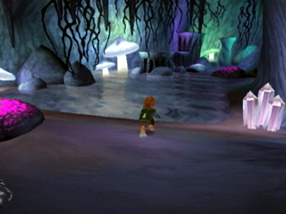
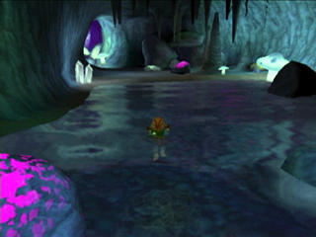
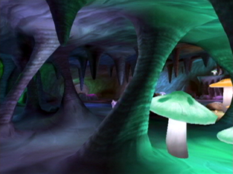
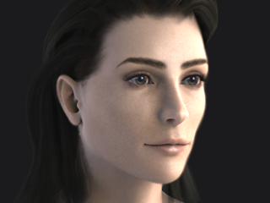
Trollhole Level, The Hobbit
In-Game, Nintendo Gamecube
Cliff caves interior

(Bilbo Baggins credits listed below)

Trollhole Level, The Hobbit
In-Game, Nintendo Gamecube
Cliff caves interior

(Bilbo Baggins credits listed below)

Trollhole Level, The Hobbit
In-Game, Nintendo Gamecube
Cliff cave interior
Young Woman
Hi-resolution render using Brazil (HDRI with 1 specular light), 3d Studio Max and Photoshop. Created as a portfolio piece. All textures were hand painted except for the specular/bump map, which was a heavily painted photo.

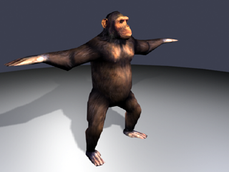
Chimp Model, Turok Evolution
1358 triangles

Source textures composited from Internet photos and Austin Zoo Photos

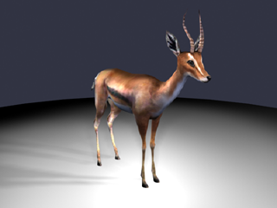
Gazelle Model, Turok Evolution
1188 triangles

Source textures composited from Internet photos and Austin Zoo

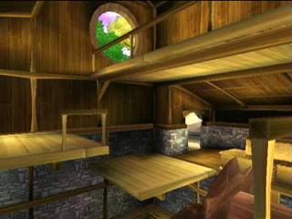
Hobbiton Level, The Hobbit
In-Game, Nintendo Gamecube
Mill Interior

Mike Fong ( http://www.fongwerx.com/ ): Hay bales

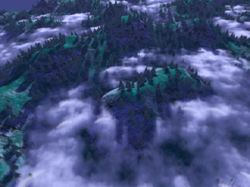
Eagleflight Test, The Hobbit
Pre-Rendered Animation of Real-Time Geometry
Technical Test for proposed Eagleflight Level

3d Studio Max stock textures used for sky, tiled grass and tiled rock

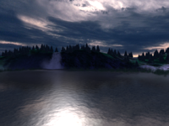
Eagleflight Test, The Hobbit
Pre-Rendered animation. Technical test for water.

3d studio Max stock textures used for sky grass and rock.

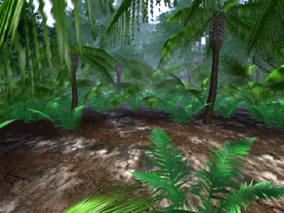
Jungle Demo, Turok Evolution
Pre-Rendered Animation of Simulated Real-time Scene
Created for in-house Green Light committee.
Lit with Projection lights—No Shadows

Robert “Buddy” Wilshire: Palm Trees

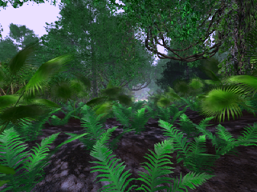
Jungle Demo, Turok Evolution
Pre-Rendered Animation of Simulated Real-time Scene
Created for in-house Green Light committee.
Lit with Projection lights—No Shadows

Robert “Buddy” Wilshire: Palm Trees

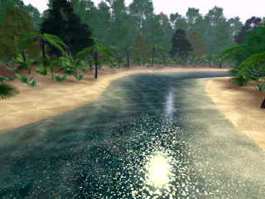
Jungle Demo, Turok Evolution
Pre-Rendered Animation of Simulated Real-time Scene
Created for in-house Green Light committee.
Lit with Projection lights—No Shadows

Robert “Buddy” Wilshire: Palm Trees

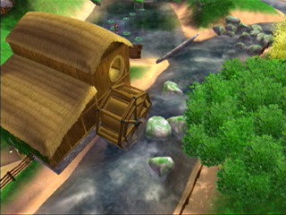
Hobbiton Level, The Hobbit
In-Game, Nintendo Gamecube

Paul Haskins: source texture for wood fence
Mike Fong ( http://www.fongwerx.com/ ): Dock behind the mill

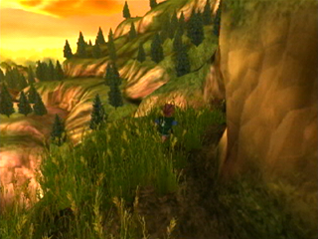
Trollhole Level, The Hobbit
In-Game, Nintendo Gamecube
Exterior Cliff

(Bilbo Baggins credits listed below)

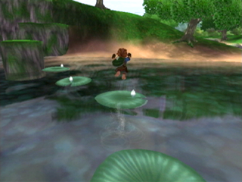
Hobbiton Level, The Hobbit
In-Game, Nintendo Gamecube

Carrie Meade: Lily pads
Martin Coven: Real-time waterfall particles
(Bilbo Baggins credits listed below)

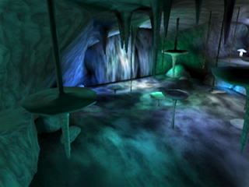
Trollhole Level, The Hobbit
In-Game, Nintendo Gamecube
Cliff caves waterfalls interior

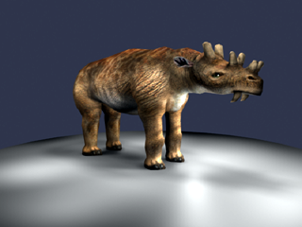
Uintatherium Model, Turok Evolution
2000 triangles
This is the ancestor of the modern deer—I don’t think they knew what one looked like before they asked me to model it.

Source textures composited from Internet photos, 3dmax source images and Austin Zoo

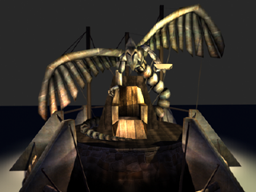
River People Elder’s Statue, Turok Evolution
Pre-Rendered Animation of Real-Time Geometry

All source textures from CD

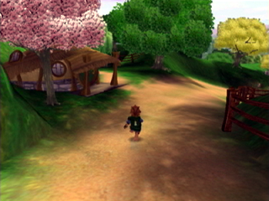
Hobbiton Level, The Hobbit
In-Game, Nintendo Gamecube

(Bilbo Baggins credits listed below)

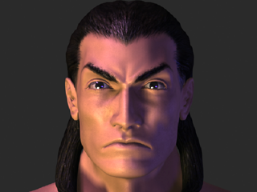
Tal’ Set, High-Poly Head, Turok Evolution
Spline model of main character created for E3 marketing animation.

Only created the head and shoulders—other artists eventually added hands and tweaked the features, as well as animating it, but what’s shown is the original, untouched by others.

The ears were modeled while at Hasbro for the game X-COM Genesis.

Brian Hagan ( www.artofhagan.com ): original paper design character sketch

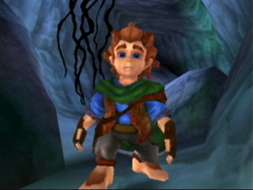
Bilbo Baggins Credits:
Tom Heineman: Design and modeling
Mike Fong ( http://www.fongwerx.com/ ): Modeling
Brad Marques: ( www.artofbrad.com ) Modeling
Jessie Slate: Animation
Martin L'Hereaux: Animation
Martin Coven: Rigging, splash and dust particles

(Note: Mike McClelland did not work on Bilbo)

