Mike McClelland

2011 Effects Reel Shot List

[www.mikemcclelland.net](http://www.mikemcclelland.net)

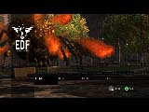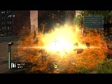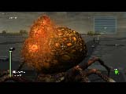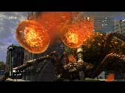

**Boomer Spider Egg sacs, EDF: Insect Armageddon (in-game PC)**

This was an attract loop for the game. Hoover Abejero created the Spider Model and Tu Nguyen did the spider and camera animations. Game-play programming was done by Alfred McNulty. I created the sacs, the particle effects and the trees. Joe Drust created the tick models. Dave Graham did most of the non-fx textures in the game.

**Tick Burst, EDF: Insect Armageddon (in-game PC)**

**Boomer Egg Sac “Muzzleflash”, EDF: Insect Armageddon (in-game PC)**

Jonathan Bishop created did all the skyboxes and lighting for the game, as well as being tech artist.

**Boomer Egg Sac detail, EDF: Insect Armageddon (in-game PC)**

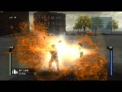

**Tick Burst Explosion, EDF: Insect Armageddon (in-game PC)**

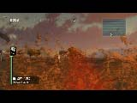

**Boomer Spider Egg Sacs, EDF: Insect Armageddon (in-game PC)**

Also green blood effect, sacs and sac burst effects

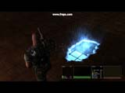

**“Schmutz”, Eat Lead (in-game PC)**

Used to replace destructible props. Lee Williamson created the “matrix” texture. This uses a homegrown parallax mapping technique, and camera controlled UV scrolling to fake the depth. Joe Drust and Abe Valdez did the modeling on the main character, with Dave Graham doing texture-work.

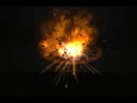

**Explosion, Blood Bath and Beyond (editor PC)**

This was also used for a marketing tutorial for the vicious engine on wired.com: <http://howto.wired.com/wiki/Make_a_Particle_Explosion_Effect>.

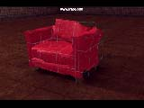

**Distortion Shader, Eat Lead (editor)**

This shader was developed for the game’s destructible props. Given the premise, the art director asked if something like this could be done instead of the usual destructible objects. Model and red texture by unknown prop artist.

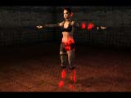

**De-Rez Shader, Eat Lead (editor PC)**

Allan Campbell developed the shader technique for the glowing edges. I wrote the final version of the shader node and used it to create de-rez versions of all the character materials in the game, resulting in more than 500 materials. Joe Drust did the model, Sue Luo and Dave Graham did character textures.

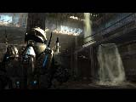

**Atrium Waterfall, GDC Engine Demo (in-game PC)**

Judd Roy was the level artist in charge and guided the scene development, with Chris Smart as Art Lead. I created the waterfall, moving water and splash effects, as well as sunbeams, birds and flying insects. Dave Schultz was prop artist. Joe Drust created the character.

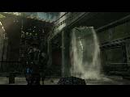

**Atrium Waterfall, GDC Engine Demo (in-game PC)**

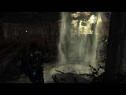

**Atrium Waterfall, GDC Engine Demo (in-game PC)**

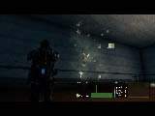

**Wind Effects, GDC Engine Demo (in-game PC)**

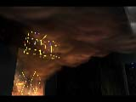

**Smoke, GDC Engine Demo (editor PC)**

Chris Smart did the level art and was Art Lead.

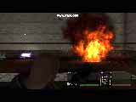

**Explosion, Eat Lead (in-game PC)**

This was for an in-game cinema. Matt Hazard character was modeled by Joe Drust and Abe Valdez, with textures by Dave Graham.

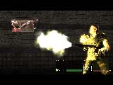

**Shotgun Muzzleflash, Eat Lead (in-game PC)**

Spencer Trent did shell casing effects. Clarence Simpson did the UI programming and animation.

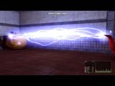

**Lightning Effect, Eat Lead (in-game PC)**

Particle effect. The teapot shader was made by Jonathan Bishop as a test effect.

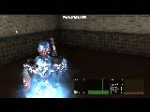

**Master Shield Effect, Eat Lead (in-game PC)**

This was a shader to indicate when the main character is bulletproof. I combined this effect with the above mentioned de-rez effect node to turn it on and off.

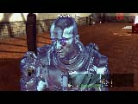

**Master Shield Effect, Eat Lead (in-game PC)**

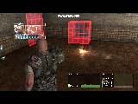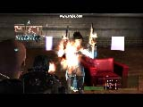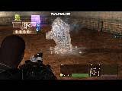

**Energy Pistol Hit, Eat Lead (in-game PC)**

**Energy Pistol Hit, Eat Lead (in-game PC)**

A distortion effect was added to give it a more futuristic look. Female Robot model by Joe Drust. Character textures by Dave Graham and Susan Luo.

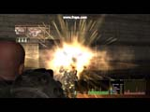

**Grenade Effect, Eat Lead (in-game PC)**

I believe Spencer Trent created the smoke trail and muzzle flash for the weapon. Space Marine by Joe Drust.

**Ice Upgrade Effect, Eat Lead (in-game PC)**

Uses a distortion effect on the frame buffer texture, as well as a mist effect. An ice shader is applied to the character as well. Game-play Programming was done by Ed Rowe. Security Guard by Joe Drust.

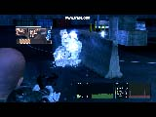

**Ice Upgrade Effect, Eat Lead (in-game PC)**

Combined with the de-rez and code cloud effects.

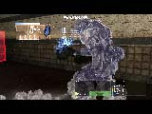

**Ice Upgrade Shader, Eat Lead (in-game PC)**

Freeze frame showing the ice shader effect. Joe Drust created the Space Marine model. The blue squares and lines of text are actually digital “blood.” Given the digital nature of the game’s fiction, it was decided that pixels and sections of code should come out when a character was shot.

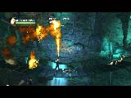

**Flamethrower Effect, Bloodbath and Beyond (in-game PC)**

Cave by Rob Maxwell.

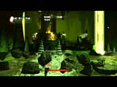

**Drill Boss Splash, Bloodbath and Beyond (in-game PC)**

I only did the splash effect in this scene. Waterfalls and smoke by Brian Ingersoll.

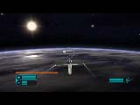

**Earth/Space Skybox, Despicable Me (in-game PC)**

Rob Maxwell created the ship.

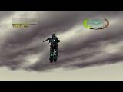

**Clouds, EDF: Insect Armageddon (in-game PC)**

This is a shader effect on geometry.

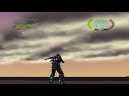

**Clouds, EDF: Insect Armageddon (in-game PC)**

This is a slight variation on the above clouds, set to look like they are lit from underneath.

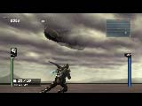

**Clouds, EDF: Insect Armageddon (in-game PC)**

The ship in this shot was done by Joe Drust, and the background (behind the clouds) was done by Jonathan Bishop.

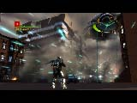

**Building Collapse, EDF: Insect Armageddon (in-game PC)**

Dave Schultz did the building and the building collapse animation. I did the effects and wrote about 70% of the script the artists used for the destructions. The other 30% I borrowed from a tool called Fracture Veronoi, by Garp, which I incorporated in with the rest of the building destruction pipeline.

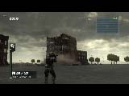

**Building Collapse, EDF: Insect Armageddon (in-game PC)**

Judd Roy did the building and the building collapse animation.

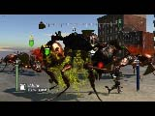

**Green Blood, EDF: Insect Armageddon (in-game PC)**

Ty Shelton created the ant models.

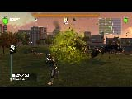

**Green Blood, EDF: Insect Armageddon (in-game PC)**

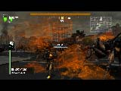

**Orange Ant Spit, EDF: Insect Armageddon (in-game PC)**

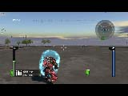

**Shield Effect, EDF: Insect Armageddon (in-game PC)**

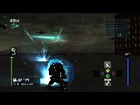

**Bubble Shield Effect, EDF: Insect Armageddon (in-game PC)**

I also did the laser and hit effects. Skybox by Jonathon Bishop.

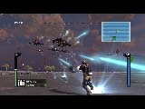

**Gunship Effects, EDF: Insect Armageddon (in-game PC)**

Joe Drust created the gunship models.

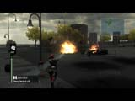

**Car Explosion, EDF: Insect Armageddon (in-game PC)**

Lee Williamson created the Car and the car pieces. Mike Nelson and Allan Campbell did the physics setup.

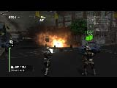

**Car and Trash Explosions, EDF: Insect Armageddon (in-game PC)**

Lee Williamson created the Car and the car pieces. Mike Nelson and Allan Campbell did the physics setup. Dave Shultz created the trash can prop.

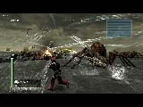

**Web Effect, EDF: Insect Armageddon (in-game PC)**

Hoover Abejero created the Spider models.

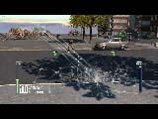

**Web Effect, EDF: Insect Armageddon (in-game PC)**

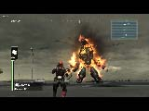

**Hector Death, EDF: Insect Armageddon (in-game PC)**

Scott Marshall did the animation, Alan Campbell did the game-play programming, Joe Drust did the Robot Model, and Dave Graham did the character textures.

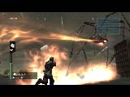

**Laser, EDF: Insect Armageddon (in-game PC)**

Alan Campbell did the game-play coding.

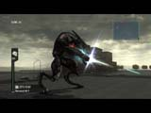

**Hector Muzzle Flash, EDF: Insect Armageddon (in-game PC)**

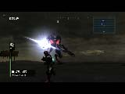

**Hector Muzzle Flash, EDF: Insect Armageddon (in-game PC)**

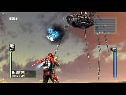

**Alien Cluster Bomb, EDF: Insect Armageddon (in-game PC)**

Kevin Mabie and Alfred McNulty did the gameplay coding. I believe Hoover Abejero created the Daddy Long Legs model.

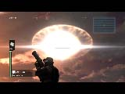

**Genocide Bomb, EDF: Insect Armageddon (in-game PC)**

This was an explosion effect created with geometry and shaders for performance reasons—full screen particles were fill-bound when we tried them. There is a sphere in the sky and also one around the camera with a depth buffer shader applied. Game-play programming by Allan Campbell.

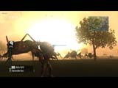

**Genocide Bomb, EDF: Insect Armageddon (in-game PC)**

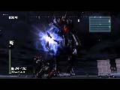

**Hector2 Laser, EDF: Insect Armageddon (in-game PC)**

Game-play programming by Alfred McNulty. Robot model by Joe Drust.