“I am Turok” Greenlight Video

Turok 4 Initial Team

~04/2000

www.mikemcclelland.net

Intro
This was a video created to greenlight the Turok Evolution video game, created in roughly a month’s time. I was responsible for the jungle backgrounds, jungle running scenes, water and some of the cliff work.

Summary of Credits:

Peyton Duncan- Art Direction/ story sequence

Mike Fong—3d Artist (http://www.fongwerx.com/ )

David Levy—3d Artist/ Concept Art

Brad Marques—3d Artist/ Compositing/ Concept Art ( www.artofbrad.com )

Mike McClelland—3d Artist

Martin Coven—3d Artist

Ben Bonner—Concept Art/ 3d Artist (www.benbonnerart.com )

Buddy Wilshire—3d Artist

Mark Mackin-- Rigging

Shot List:

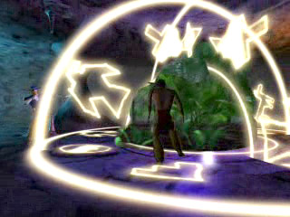
Mike Fong—shot setup, effects, animation, and cave.
Brad Marques—Characters
Ben Bonner—Character Designs
Mike McClelland-- Jungle

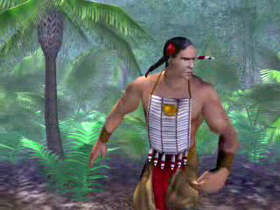
Brad Marques—Character and animation
Mike McClelland—Scenery
Buddy Wilshire—Palm Tree

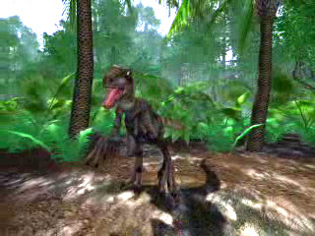
Peyton Duncan—Raptor and Raptor animations
Mike McClelland—Scenery
Buddy Wilshire—Palm Tree

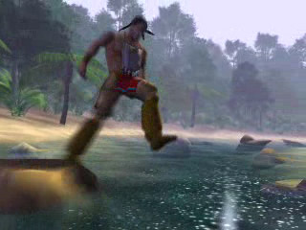
Brad Marques—Characters and animation
Mike McClelland—Scenery
Buddy Wilshire—Palm Tree
Ben Bonner-- Rocks

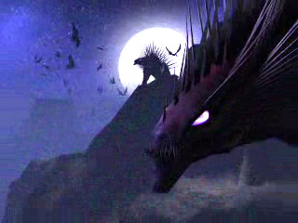
Mike Fong—all.

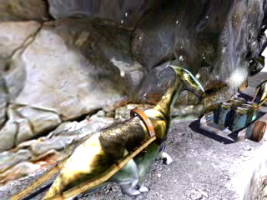
David Levy—Dinosaurs
Mike McClelland-- Cliff

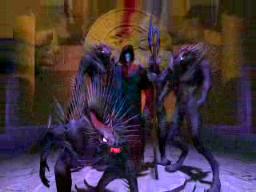
Mike Fong—all.

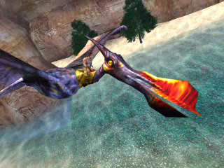
David Levy—Dinosaur and animation
Mike McClelland—Cliff background/ water
Brad Marques-- Character

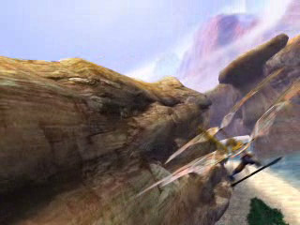
David Levy—Glider, dinosaur, animation and skybox
Mike McClelland—Cliff background (water, trees and beach used from jungle)
Brad Marques-- Character

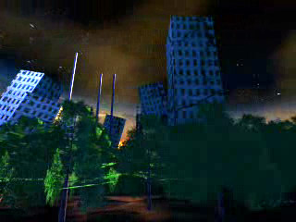
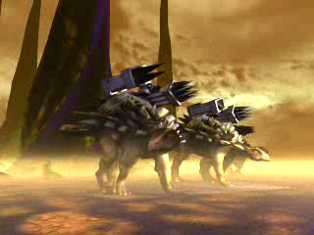
David Levy—scenery and animation
Mike McClelland—tree (pulled from Jungle sequences)

Mike Fong-- all

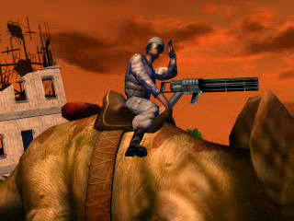
Peyton Duncan—all (skybox image from autodesk maps)

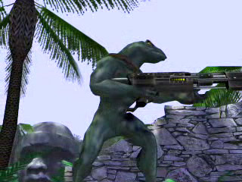
Martin Coven—Dinosoid and weapon
Peyton Duncan—animation
Mike McClelland—scenery/ props
Mark Mackin—source photo for stone head
Buddy Wilshire—Palm Tree

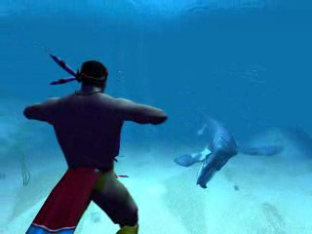
Brad Marques—Character and animation
David Levy—Dinosaur (scenery?)

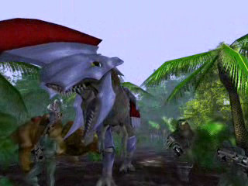
Mike Fong—Animation, Shot setup, Dinosaur, Roman helmet, possibly Dinosoids?
Martin Coven—Possibly Dinosoids?
Mike McClelland—Scenery
Buddy Wilshire—Palm Tree

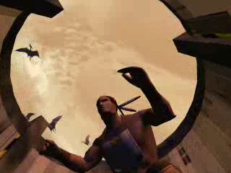
Brad Marques—Character
Mike Fong—Everything else

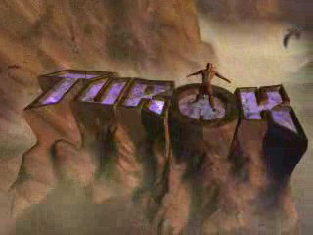
Brad Marques—Character
Mike Fong—Everything else

