Mike McClelland

Vicious Engine Effects Reel

www.mikemcclelland.net

Intro
This is a compilation of Fraps videos taken during the development of “Eat Lead” and for the GDC demo immediately afterwards. Right after I signed on to the project, the game’s premise became a sci-fi/ matrix style shooter, with distortion and “de-rez” effects. The effects shown here was a part of that revision. The end result was the creation of more than 1200 materials and 560 geom/particle emitter templates (roughly speaking, over 250 particle effects).

Summary of Credits:

Mike McClelland- All material effects and particles except where otherwise indicated. Additionally, some scene geometry, polish and lighting.

Art Direction- Alden Filion (also all cinematics, level art and lighting)

Character Models- Joe Drust (Lead), Abe Valdez, Ty Shelton

Concepts- Matt Kohr, Susan Luo

Scene Textures- Dave Graham, Susan Luo, Matt Kohr (also UI)

Level Art- Jonathan Bishop (Level Lead), Chris Smart, Judd Roy, and Jonathan Albert

Props- Lee Williamson (Prop Lead), Adrian Castro, Jonathan Albert, David Schultz

Animation- Steve Wassaf, Scott Marshall, Lianne Cruz, Henry Schwetzke

Music- “Loveless” by Spylab

Shot List:
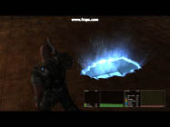
Schmutz Effect (PC game engine)
This was put in place after a destructible object went away. Lee Williamson was the source for the vertical “code” texture entering into and out of the hole. This uses a homegrown parallax mapping technique, and camera controlled UV scrolling to fake the depth. Joe Drust and Abe Valdez did the modeling on the main character, with Dave Graham doing texture-work.

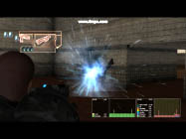
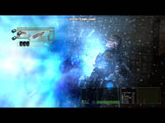
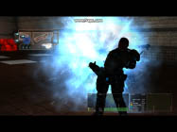
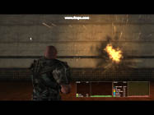
Plasma Rifle Effects (PC game engine)
Charge up, muzzle flash and hit effect. This was a Space Marine weapon. A slight distortion shockwave effect was a part of this.

Plasma Rifle Effects (PC game engine)
Freeze-frame showing the details of the plasma hit effect. Joe Drust created the Space Marine model.

Plasma Rifle Effects (PC game engine)
Another freeze-frame showing the plasma hit effect

Fire Explosion effect (PC Game Engine)
Used in a marketing tutorial on Wired.com: http://howto.wired.com/wiki/Make_a_Particle_Explosion_Effect.
Basic Explosion, Mid-Air (PC game engine)

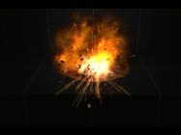
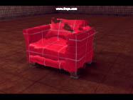
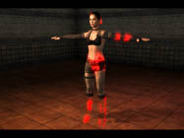
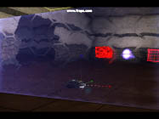
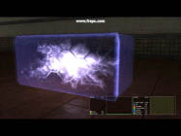
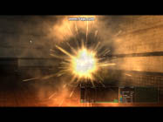
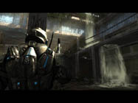
Distortion Shader (editor)
This shader was developed for the game’s destructible props. Given the premise, the art director asked if something like this could be done instead of the usual destructible objects. Model and red texture by unknown prop artist.
De-Rez Shader (editor)
I worked with programmer Allan Campbell to get this up and going. Allan did the implementation and developed the glowing edges technique used in the shader. I wrote the final version of the shader node and used it to create de-rez versions of all the character materials in the game, resulting in more than 500 additional shaders. Joe Drust did the model, sue Luo and Dave Graham did character textures.
Master Chef Shield Shader (editor)
One of the characters can spawn shield objects to hide behind. This shader was created for that purpose. Based on a concept by Matt Kohr.
Master Chef Shield (PC game engine)
Freeze frame. Created from a concept drawing by Matt Kohr. Uses the above shader and a particle effect.
Basic Explosion, Mid-Air (PC game engine)
Freeze-frame detail of the above effect

Atrium Waterfall—Judd Roy was the level artist in charge and guided the scene development, with Chris Smart as Art Lead. I created the waterfall, moving water and splash effects, as well as sunbeams, birds and flying insects. Dave Schultz was prop artist. Joe Drust created the character. This was created for the Vicious Engine Demo at GDC.

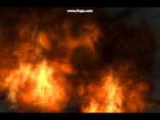
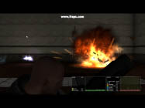
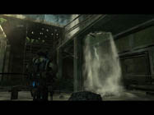
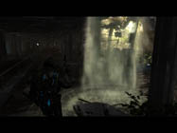
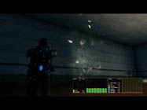
Fire Effect (editor)

Wind Effects for Office scene. This was created for the Vicious Engine Demo at GDC.
Cinematic Ground Explosion (PC game engine)
This effect was for an in-game cinema.
Atrium Waterfall
Atrium Waterfall

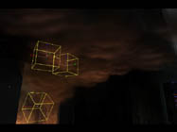
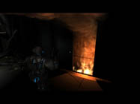
Smoke/Flame for Office scene. This was created for the Vicious Engine Demo at GDC. Chris Smart did the level art and was Art Lead.
Smoke/Flame for Office scene. This was created for the Vicious Engine Demo at GDC. Chris Smart did the level art and was Art Lead.

.

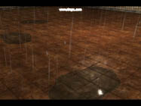
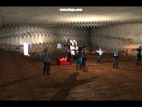
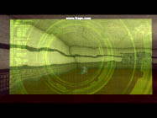
Green Hack UI Effect (editor)
Matt Kohr did the initial UI concept for this effect. When the good guys were hacking into your level to help you, this effect was to come up. Matt created the ring textures in Photoshop, and I imported and animated them in the shaders. I created the grid and the distortion shaders, as well as the animated shaders on the text and images in the corners. It’s a reference to developers and includes diagrams of caffeine, nicotine, sucrose, and testosterone.

Rain/Puddles (editor)
Wall Distortion Effect (editor)
This was used as a subtle effect in cinematic backgrounds to indicate that not all is quite right in the world—like a glitch in the matrix.

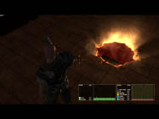
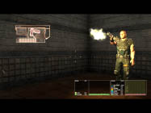
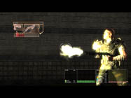
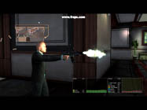
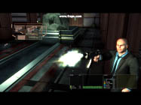
Hazard Pistol Muzzle Flash (PC game engine)
Particle Effect. Kevin Mabie and Allan Campbell implemented most weapons effects. Clarence Simpson did the UI programming and animation.
Shotgun Muzzle Flash (PC game engine)
Given the short time frame, whenever possible I tried to change existing effects, rather than start new effects from scratch. The Shotgun, the Uzi, and the Hazard pistol effects were cloned from each other and changed accordingly to match the weapon’s style. Spencer Trent did shell casing effects. Clarence Simpson did the UI programming and animation.

Uzi Muzzle Flash, rotation (PC game engine)

Uzi Muzzle Flash (PC game engine)
Ty Shelton created the model of the main character wearing a suit. Chis Smart made the background, with Jonathan Albert doing additional level art. Spencer Trent did 3D shell casing effects. Clarence Simpson did the UI programming and animation.
Zombie Pit (PC game engine)
This shows some of the parallax mapping and depth techniques discussed above. Hole geometry is a single plane of 2 triangles.

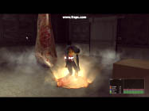
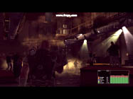
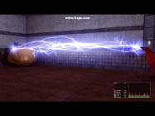
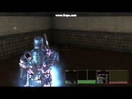
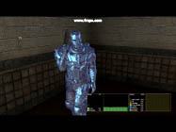
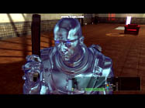
Zombie Spawn (PC game engine cinematic)
I believe Alden Filion did the level work art and lighting for this area, as well as the cinema. Allen Campbell did effects implementation.

Dance Club Area (PC game engine)
This is one of the level areas I worked on. I did the lighting and effects shown here, as well as some level geometry and polish. I also spent a good bit of time working on collision in this area. The light beams are geometry, with a shader made to fade out when seen edge on. Judd Roy did the original build out and Adrian Castro and Lee Williamson made props. The dancing “Hoover” was made by an unknown artist as a temporary test.
Lightning (PC game engine)
Particle effect. The teapot shader was made by Jonathan Bishop as a test effect.
Master Shield Effect (PC game engine)
This was a shader to indicate when the main character is bulletproof. I combined this effect with the above mentioned de-rez effect node to turn it on and off.
Master Shield Effect (PC game engine)
Freeze frame showing details of shield effect.
Master Shield Effect (PC game engine)
Freeze frame showing details of shield effect.

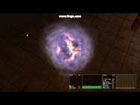
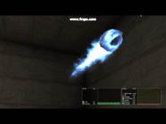
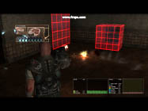
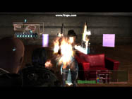
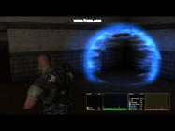
Original Code Cloud (PC game engine)
This static effect was to be the pickup when NPC’s died. Unused in-game.
Meteor Effect (PC game engine)
Particle and shader effects. Hoover Abejero modeled and textured the bare rock underneath the effect. The shipped version of this effect needed to be adjusted because the in-game meteor had a variable orientation and velocity.
Energy Pistol (PC game engine)
Space Marine weapon. A quick, rapid-fire particle effect.

Energy Pistol (PC game engine)
A distortion effect was added to give it a more futuristic look. Female Robot model by Joe Drust. Character textures by Dave Graham and Susan Luo.

Bill the Wizard’s Shield (PC game engine)
This started as the proxy for the Master Shield effect, but a ball filling up 1/3 of the screen didn’t work out so well. It was eventually used for an NPC.

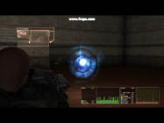
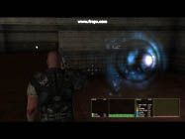
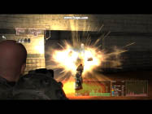
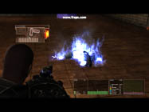
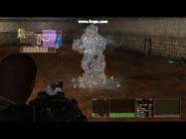
De-rez gun effect (PC game engine)
This effect was supposed to suction code away from you—one shot, one kill. Uses a bit of frame buffer distortion.

De-rez gun effect (PC game engine)
The effect seen from an angle.

Fire Upgrade (PC game engine)
Weapons were able to be upgraded to use either fire or ice. Blue flames were used instead of a more realistic flame, in order to be more ratings-friendl. I’m unsure as to whether Abe or Joe developed this character model. Programming was done by Ed Rowe.

Ice Upgrade (PC game engine)
Uses a distortion effect on the frame buffer, as well as a mist effect. An ice shader is applied to the character as well. Programming was done by Ed Rowe.

Grenade Effect (PC game engine)
This started as a basic grenade, firing from the ground. But a large number could be fired at once and smoke needed to go away quickly. Also, these acted like an RPG (explode mid-air on impact) when hitting the characters, and a regular grenade (from the ground) when hitting anything else—so something more radial, small and fast needed to be made, with less ground effect. I believe Spencer Trent created the smoke trail and muzzle flash for the weapon.

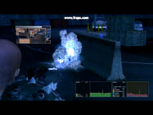
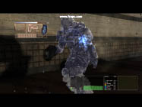
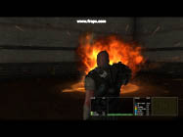
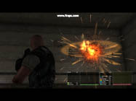
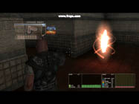
Ice Upgrade (PC game engine)
Combined with the de-rez and code cloud effects.

Ice Upgrade Shader (PC game engine)
Freeze frame showing the ice shader effect. Joe Drust created the Space Marine model. The blue squares and lines of text are actually digital “blood.” Given the digital nature of the game’s fiction, it was decided that pixels and sections of code should come out when a character was shot.

Cinematic Ground Explosion (PC game engine)
Freeze frame detail of an explosion effect.
Cinematic Mid-Air Explosion (PC game engine)
Created for an in-game cinema
Employee Teleport Effect (PC game engine)
Programmers from the “real” world were able to teleport into the game—this effect appeared when they did so.

Bill the Wizard’s Shield (PC game engine)
This started as a proxy for the Master Shield effect, but a ball filling up1/2 of the screen didn’t work out so well. I finally used it for an NPC.

Note: All shots were recorded using fraps, either within the PC editor or game engine. After FX was used for the editing, and used to adjust levels and saturation in some shots, but otherwise no compositing effects, no post effects, and no filters have been used. All effects textures, materials and meshes were created from scratch for Vicious Cycle. Effects were created in the Vicious Engine. Copyright 2009 Vicious Cycle Inc., All Rights Reserved.
Employee Teleport Effect (PC game engine)
Programmers from the “real” world were able to teleport into the game—this effect appeared when they did so.

